**Assignment – II**

**Name – Harsh Shah Jaiswal**

1. **Create command in SQL.**

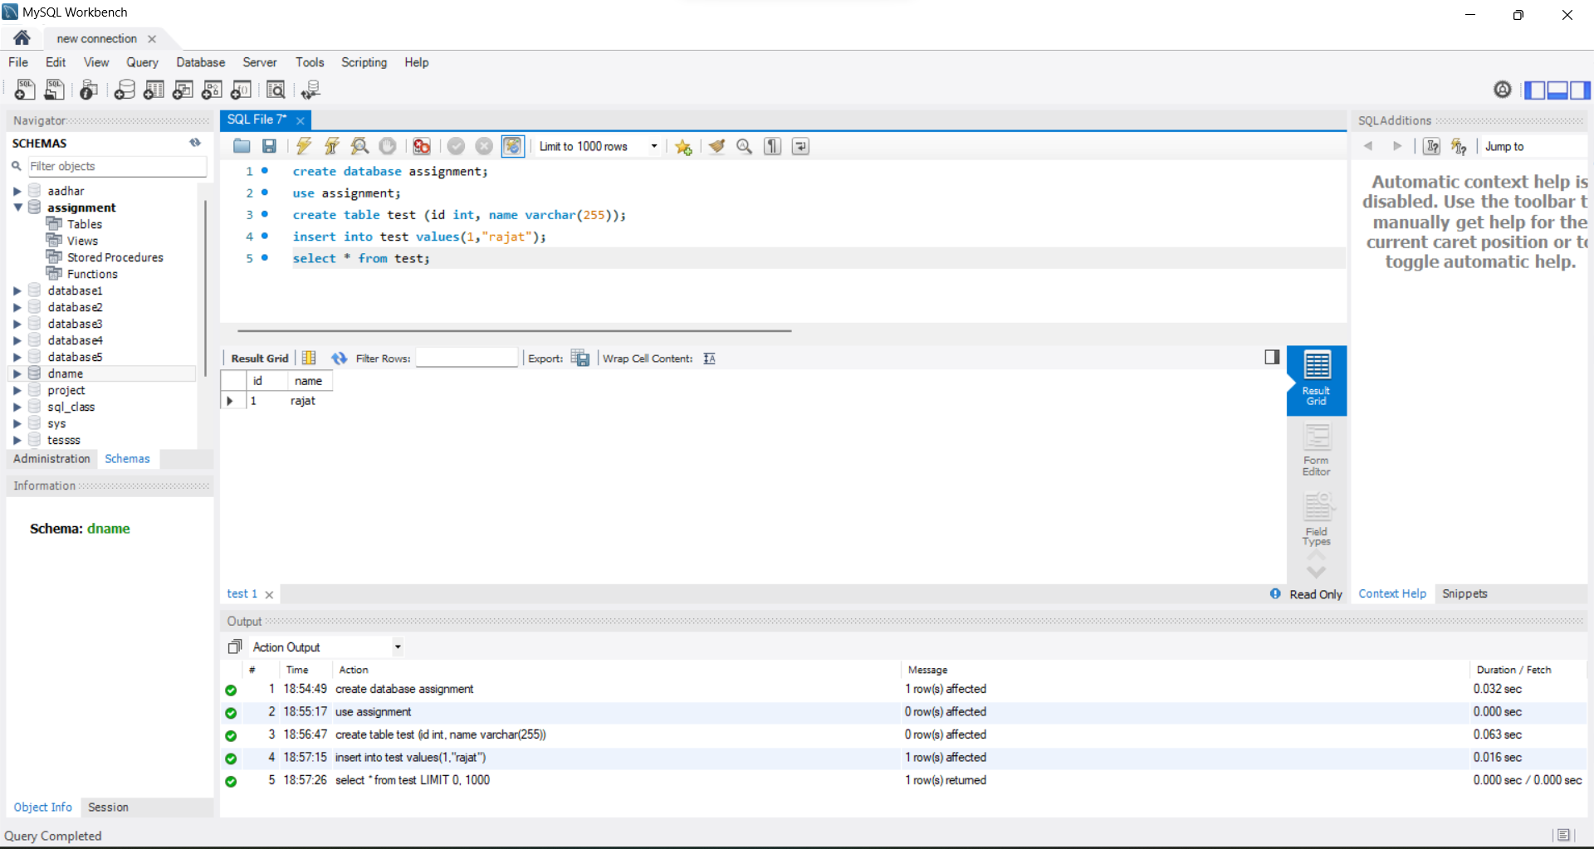

1. **UPDATE command in SQL**

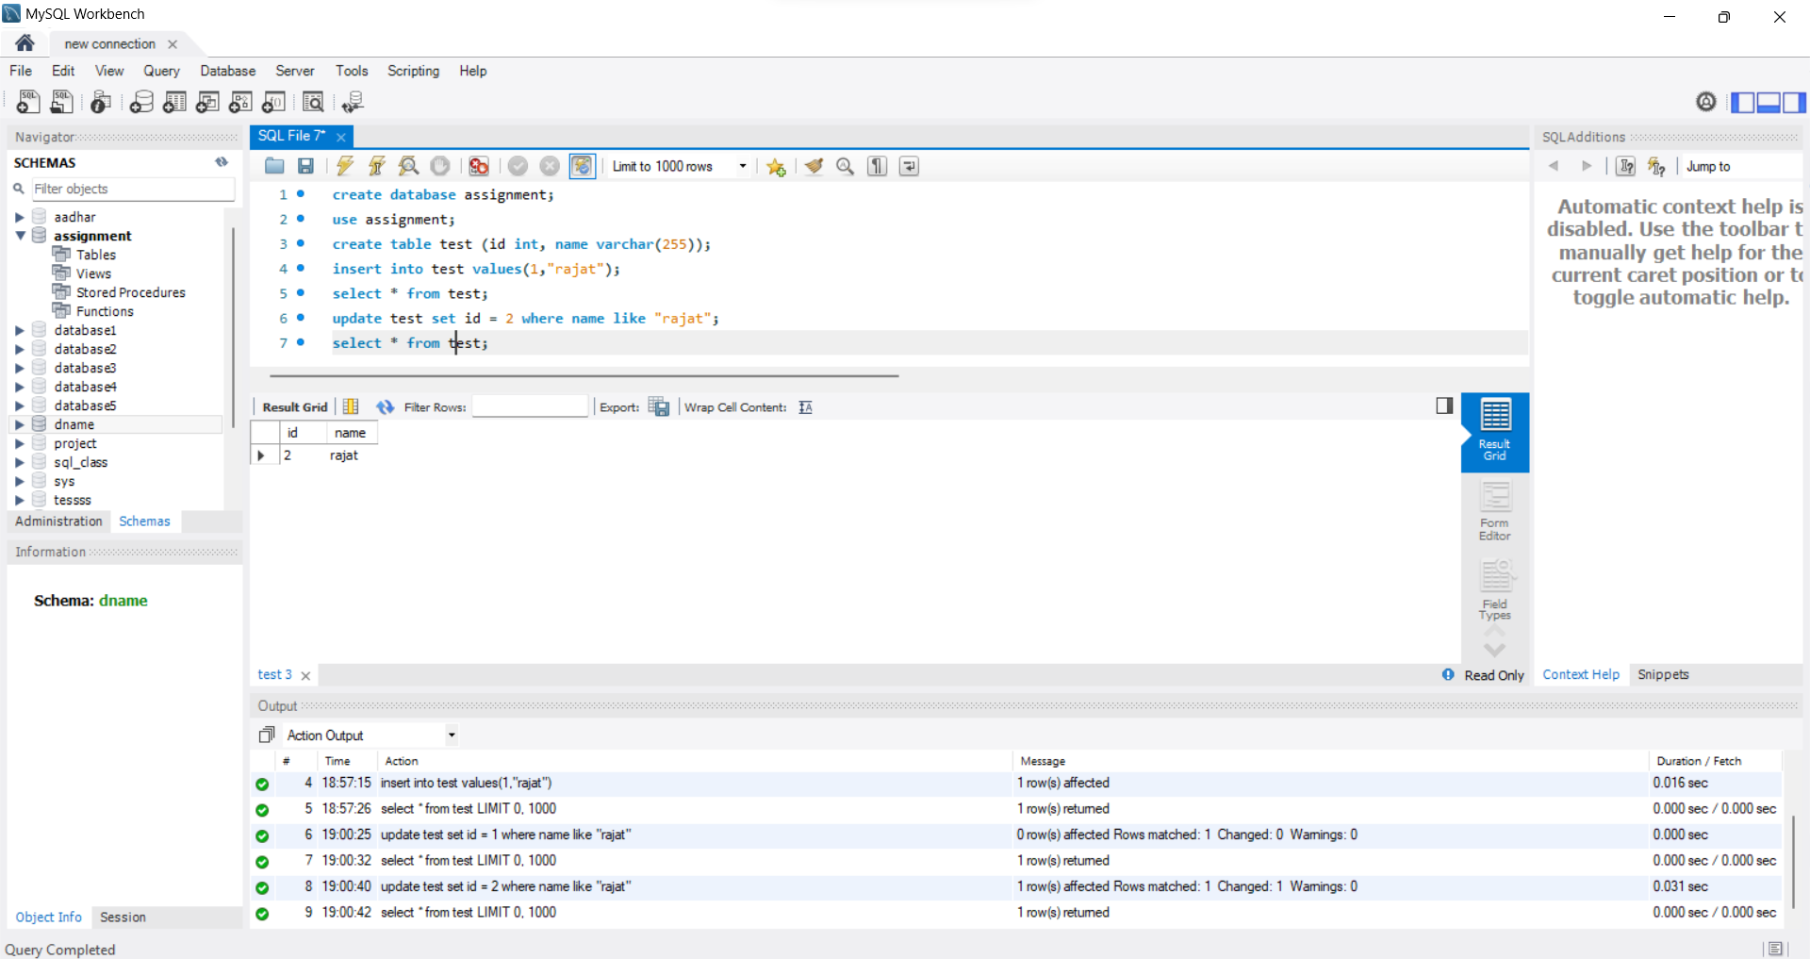

1. **DELETE command in SQL**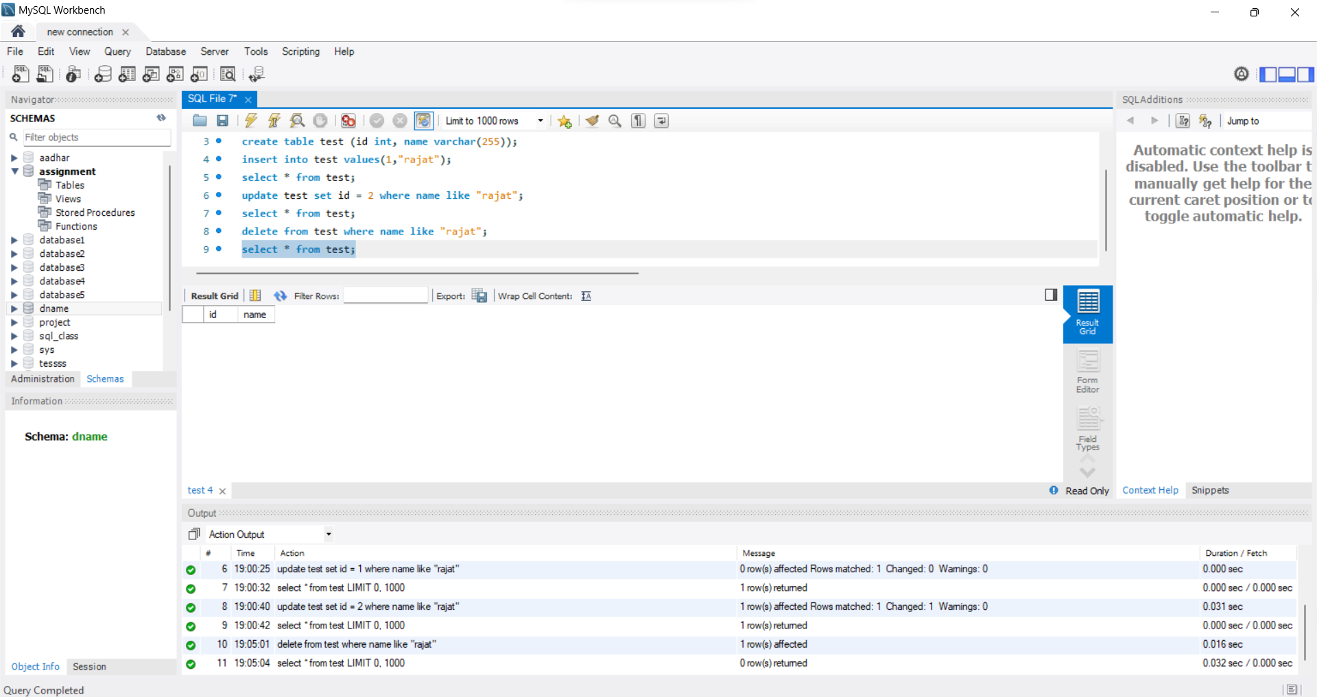
2. **Creating tablesA screenshot of a computer

   Description automatically generated with medium confidence**

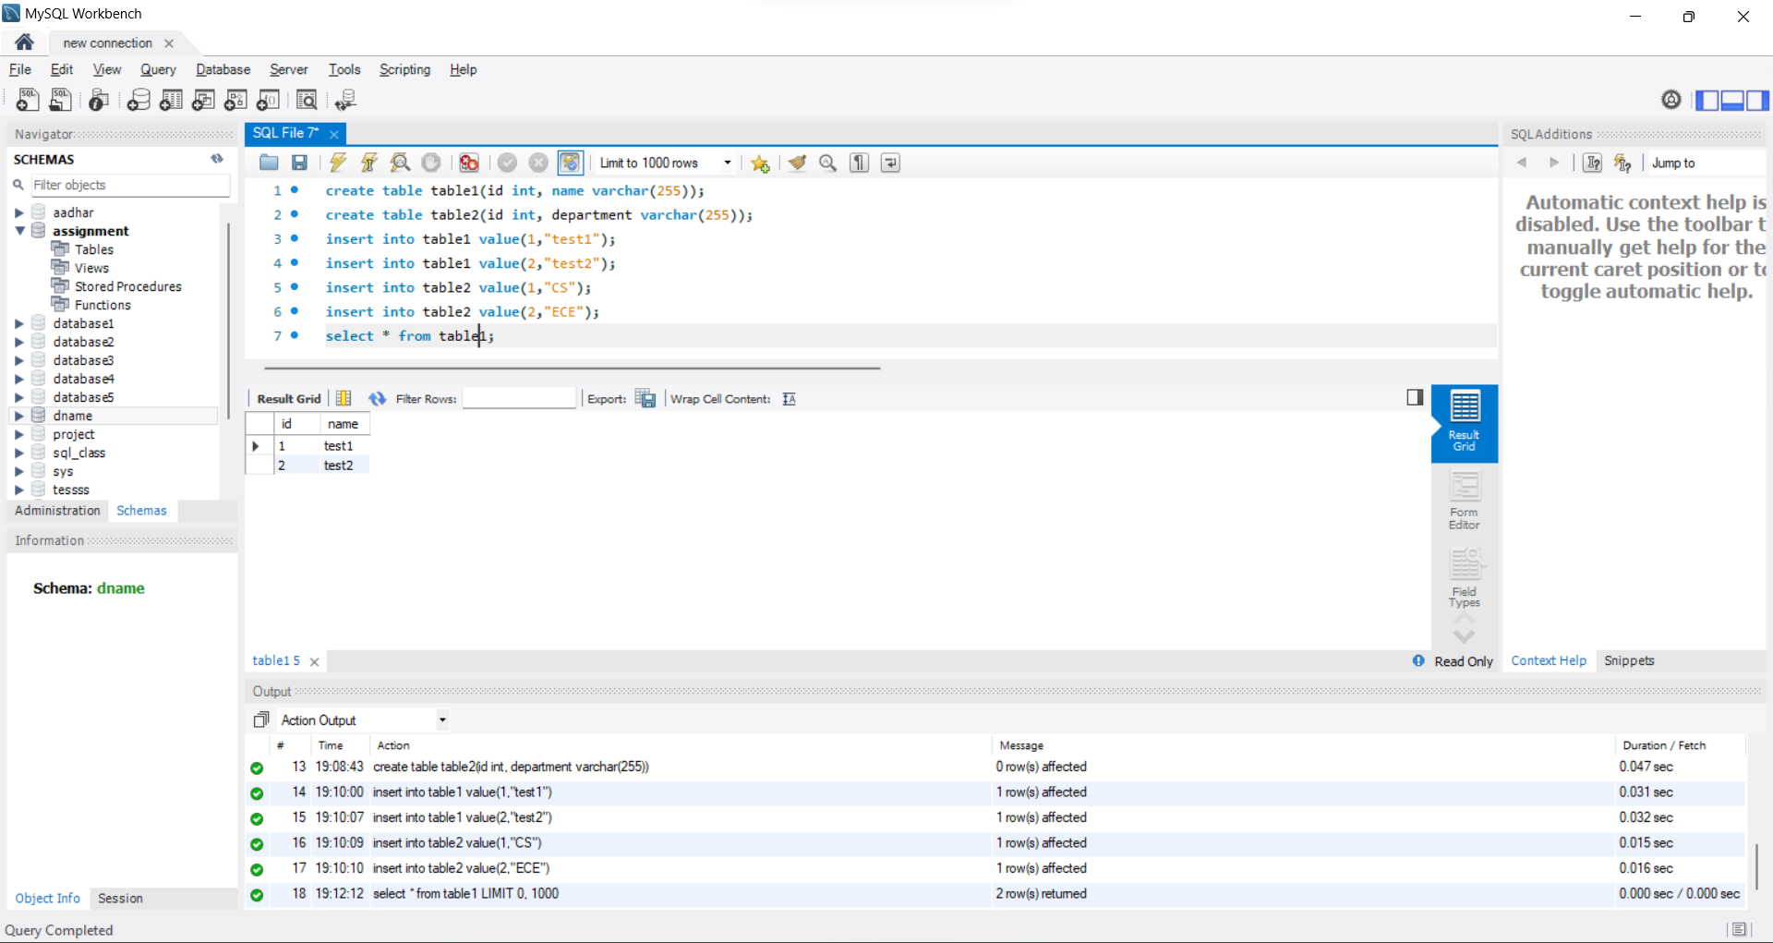

1. **Left Join**

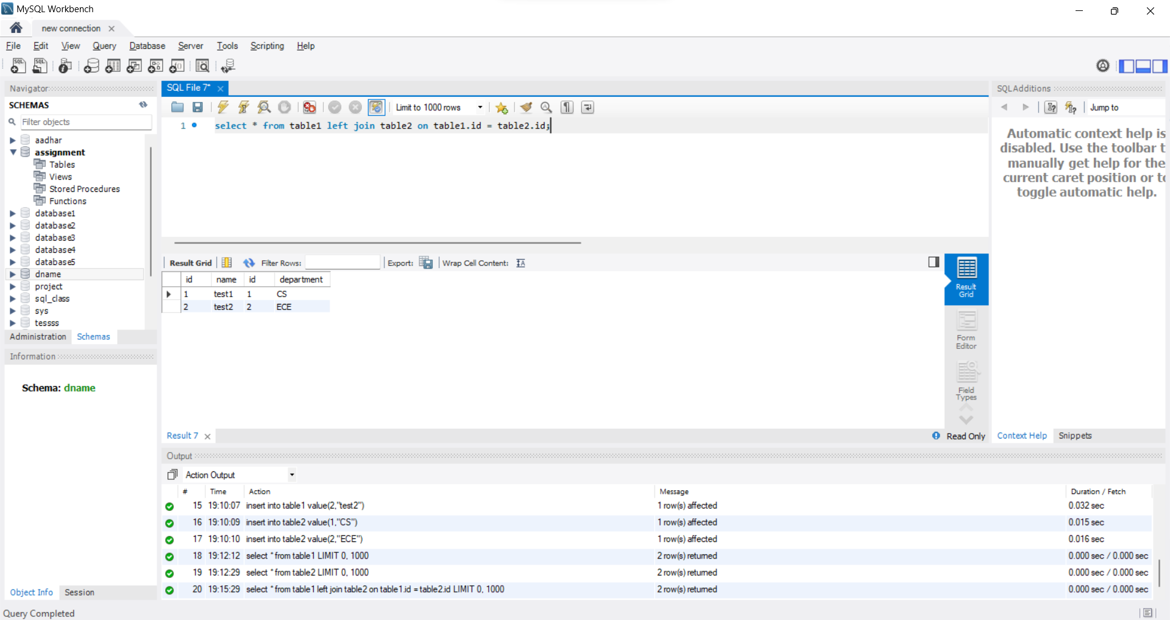

1. **Inner JoinA screenshot of a computer

   Description automatically generated with medium confidence**
2. **Full outer join**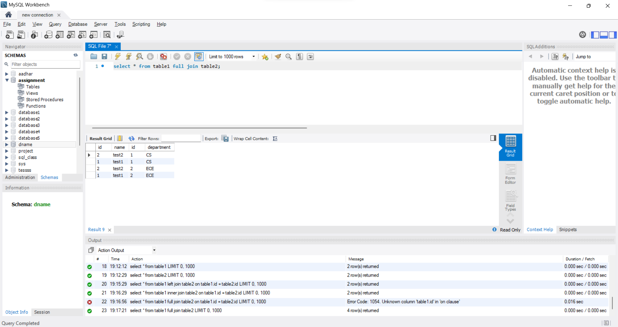
3. **Right JoinA screenshot of a computer

   Description automatically generated with medium confidence**
4. **Create in MongoDB**

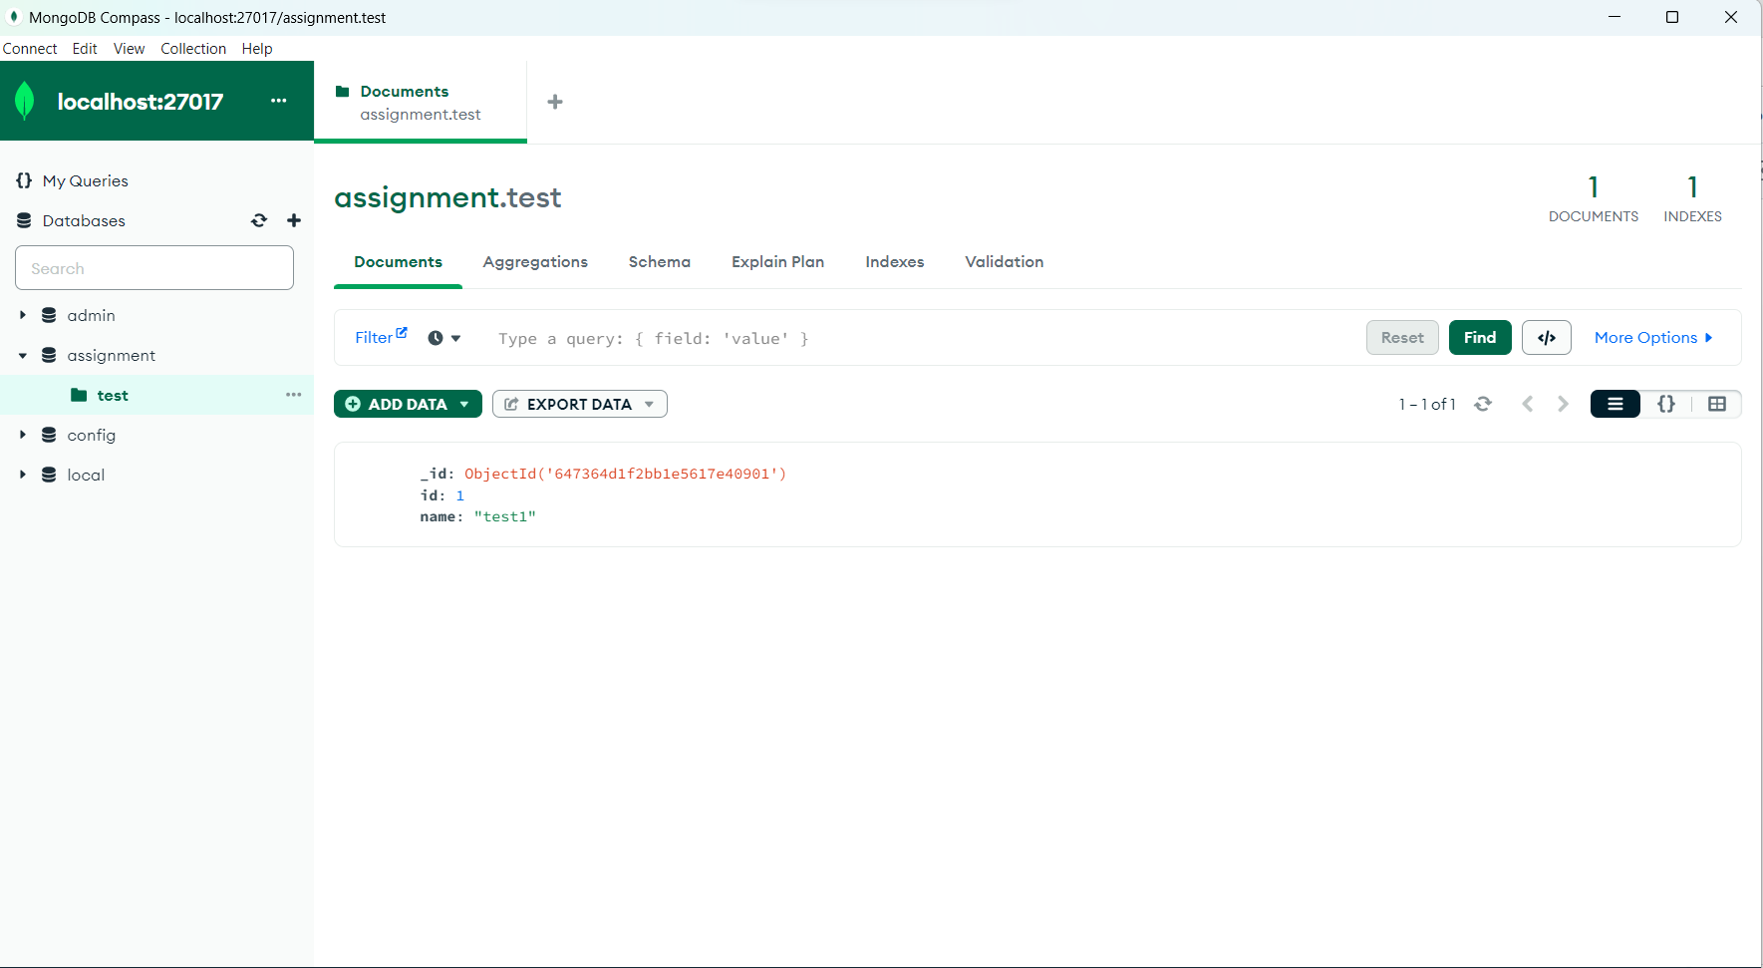

1. **Update in MongoDBA screenshot of a computer program

   Description automatically generated with medium confidence**

1. **DELETE in MongoDBA screenshot of a computer program

   Description automatically generated with medium confidence**

